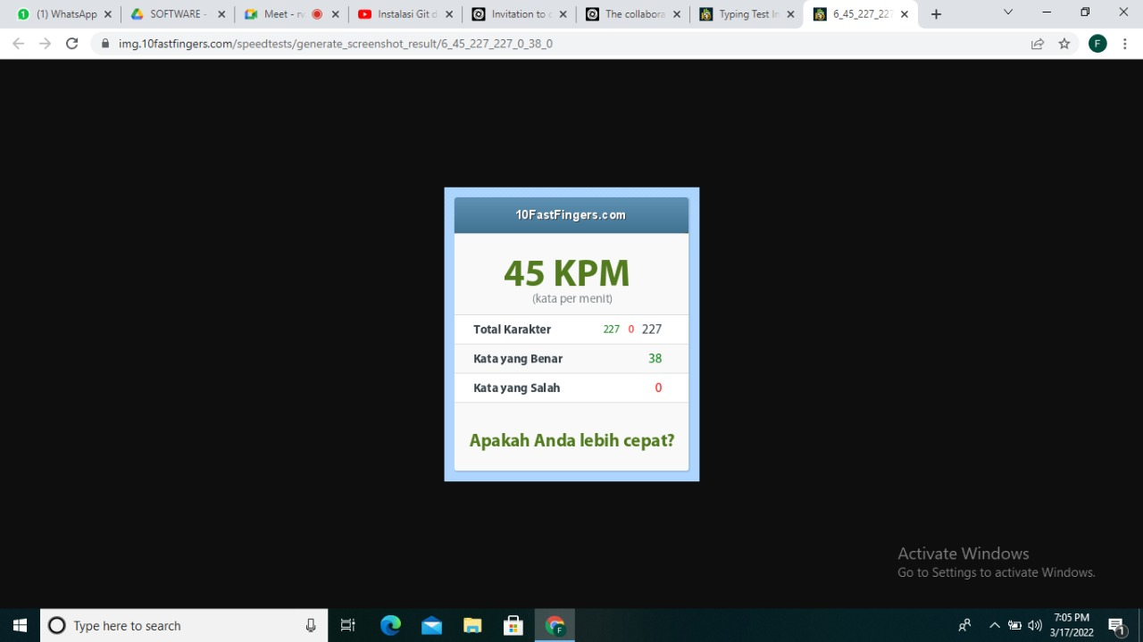Link repo : <https://github.com/PaulJoych/Simple-Calculator.git>

